HYSTERECTOMY
Lien Youtube de la vidéo : https://youtu.be/hn8Jf6nfv7c
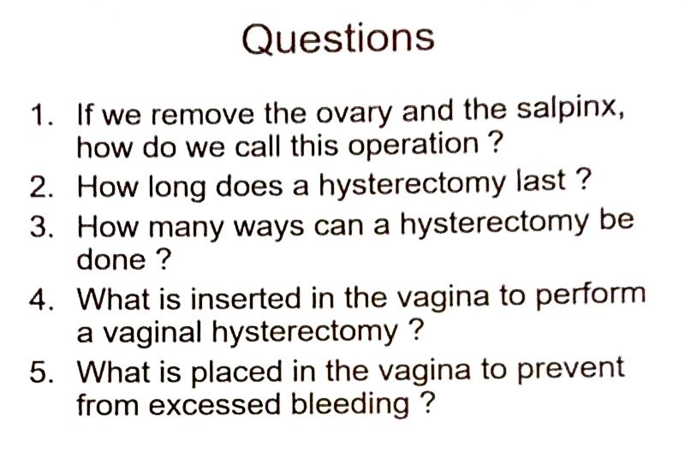
  - Hysterectomy with salpingo-oophorectomy
  - 1 to 3 hours
  - Three hours
  - Weighted speculum
  - Gauze packing

Abdominal hysterectomy
For abdominal hysterectomy, your surgeon will make an incision in lower abdomen. Pull back the muscles to expose the uterus. Cut all ligaments and tissues holding the uterus in place. And remove the uterus through the abdominal incision
If your procedure includes a salpingo-oophorectomy, your surgeon will remove the ovaries and the fallopian tubes in the same manner
Procedure : an act or a manner of proceeding any action or a process (operation)
Salpingo-oophorectomy : removal of the salpinx and the ovaries
The fallopian tubes : extreme part of the salpinx which is in contact with the ovary

Vaginal hysterectomy
For vaginal hysterectomy, a weighted speculum is inserted into your vagina to stretch and hold it opened. Your surgeon will make an internal incision around the cervix, cut all ligaments and tissues holding the uterus in place and slide the uterus out through the vagina

Weighted speculum : speculum kept in place with heavy part
To strecth : to open large
To slide the uterus out through the vagina : To pull the uterus out of the body through the vagina

Laparoscopic assisted vaginal hysterectomy
For the laparoscopic assisted vaginal hysterectomy, your surgeon will create several small incisions called ports in your abdomen. Carbon dioxyde gas is then pumped through one of the ports to pump up the abdomen so its contents can be viewed more easily.
    - Ports : holes from which camera and instruments are inserted inside the abdomen
    - Carbon dioxyde gas : CO2
    - Contents : all organs in the abdomen
Your surgeon will then insert a laparoscope through one of the ports. Images from its camera are projected on to a video monitor in the operating room
    - Video monitor : screen of a TV set
    - Operating room : operating theatre, place where the operation is performed
Watching on the monitor, your surgeon will slip specialized surgical tools through the other ports and use them to make incisions around the cervix, cut the uterus free from its supporting ligaments and tissues, and pass it out through the vagina. A laparoscope can also be used in salpingo-oophorectomy.
Tools : surgical instruments
Laparoscope : intrument inserted in the abdomen through a port which contains cold light and camera
Finally, your surgeon will close the incision on your abdomen with stitches. In all three hysterectomy procedures, the top of the vagina is stitched closed and gauze packing is placed int the vagina to prevent excess bleeding
Stitches : surgical closing of a wound, one complete movement of a threaded needle
Gauze packing : surgical dressing of loosely woven cotton
Woven : past participle of To weave = to interlace
To prevent : to avoid
Excess bleeding : bleeding more than usual

